ASSIGNMENT # 01



Spring 2023
Computer Programming Theory

Submitted by: JAMAL KHAN
Registration No. : 22PWCSE2203
Class Section: B

“On my honor, as student of University of Engineering and Technology, I have neither given nor received unauthorized assistance on this academic work.”

Student Signature: ______________

Submitted to:
Dr. M Athar Sethi
May 30, 2023

Department of Computer Systems Engineering
University of Engineering and Technology, Peshawar
Implementation Of 8x1 Multiplexer Using If Else Structure
- Source code:
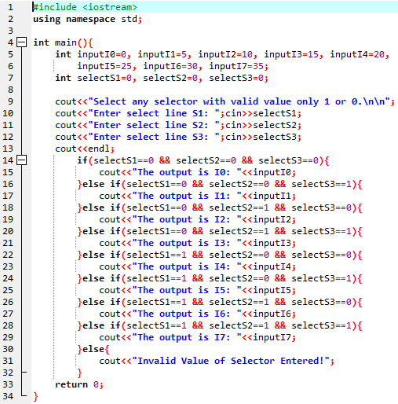

- Output:
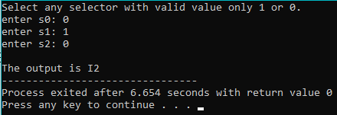

Implementation Of 8x1 Multiplexer Using Conditional Structure
- Source code:
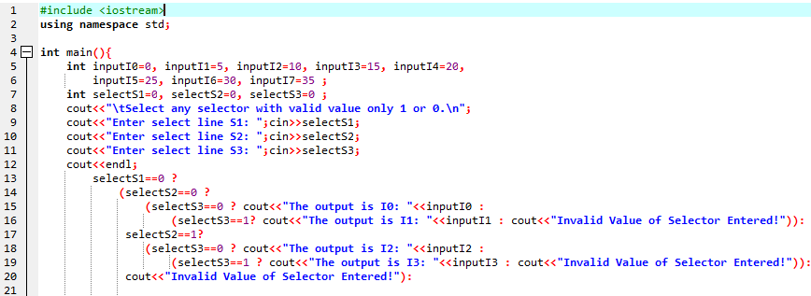
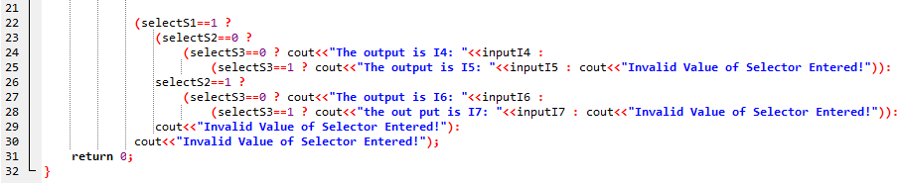
- Output:
